Recording  Progress |  | An observation related to biodiversity and interdependence in Science might look like this:
First Observation | Emily was able to identify different kinds of plants in the outdoor space and talk about what they look like. ‘It a white daisy’. She watered the nursery daffodils and understood that all plants need water to grow. ‘Plants need drinks like me’.  30.4.18 |  | (Words Up) Comments/Questions an adult might make during interactions to ascertain Emily’s understanding and support oral language development:
Child: ‘This one is big’
Adult: ‘The daffodil is big and it has a long stem and green leaves.’

Child: ‘The bee buzzed at this one’
Adult: ‘So it did, the bright red petals attract bees!’

Child: ‘I like carrots’
Adult: ‘So do I, carrots need sunlight and water to grow.’

Child: ‘This one is little’
Adult: ‘Yes, this daffodil is smaller than the other one’

Child: ‘The plants are in the greenhouse.’
Adult: ‘It’s warm in the greenhouse, heat and good soil help tulips and other plants to grow bigger and taller.’

Adult: ‘I wonder what the sunflower seed might need to help it grow?’ Pause and wait for a response
Next Observation | Emily planted, watered and grew her own broad bean seed. She was able to record the steps in the process through mark making. She was then able to talk, in sequence, about how the seed had grown to a plant. She shared this with her friends and her Dad.  23.6.18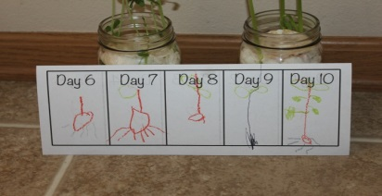

Recording  Progress | An observation related to the Food Experience and Developing Healthy Choices in HWB might look like this: | (Words Up) Comments/Questions an adult might make during interactions to ascertain Alfie’s understanding, support oral language development and facilitate learning conversations:
First Observation | Alfie joins in with social snack, eats familiar foods and is beginning to try unfamiliar foods. He is able to express his preferences for some food types. ‘I like that one’ (pointing to the kiwi).  24.2.18 | Child: ‘I like that one’. (Pointing at the kiwi fruit)  Adult: ‘Oh, you like the kiwi fruit. So do I, it’s delicious.’  Child: ‘I cut the potato’  Adult: ‘Yes, you learned to peel the potato and then chop it with the knife! Well done!’  Adult: ‘I wonder what else we can make with these vegetables?’ Pause and wait for a response  Adult: ‘I wonder what we need to eat more of to keep us strong and healthy?’ Pause and wait for a response  Child: ‘I cut all the carrot, there’s 5.’  Adult: ‘So there is, you’ve learned to count up to 5! Good counting skills!’
Next Observation | As snack helper, Alfie was able to prepare snack by washing and chopping carrots and apples. He demonstrated, through conversations with his peers, that he understood fruit and vegetables to keep our bodies healthy. ‘Carrots make me strong’.  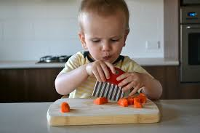  11.6.18

Recording  Progress | An observation related to Tools for Writing in Literacy and English might look like this: | (Words Up) Comments/Questions an adult might make during interactions to ascertain Claudia’s understanding, support oral language development and facilitate learning conversations:
First Observation | Claudia chooses to make marks to communicate information and can explain what they mean. ‘It’s a giraffe’. She uses a pincer grip and tripod grasp to manipulate writing materials with control.  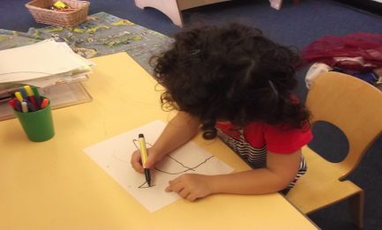  12.6.18 | Child: ‘It’s a giraffe.’  Adult: ‘So it is, you’ve drawn your giraffe with a long neck and a pattern on its body.’  Child: ‘This one is a circle.’  Adult: ‘Well done, you held the pencil steady to go up, round and down to make a circle shape!’  Child: C is the same as the one in my name.’  Adult: ‘That’s right, it’s a c for castle and Claudia. Let’s look for some more c’s.’  Child: ‘Mum starts with m.’  Adult: ‘Yes, Mum starts with m and ends in m, Mmmummm. I wonder what other words start with m?’ Pause and wait for a response  Adult: ‘Look, Claudia has made a sign for our shop.’  Child: ‘It says open and this side says closed.’  Adult: ‘That’s right, the sign says open and closed. These words tell us when we can come in and out of the shop. I wonder what other words we can see in the shop?’ Pause and wait for a response
Next Observation | Claudia was writing in a floor book about her castle. She can represent some letter sounds (phonemes) with their symbols (graphemes).  3.9.18

Recording  Progress | An observation related to Money in Numeracy and Maths might look like this: | (Words Up) Comments/Questions an adult might make during interactions to ascertain Claudia’s understanding, support oral language development and facilitate learning conversations:
First Observation | During role play Jack used counters to represent money to pay for his bus ticket. ‘I got pennies for the bus.’  27.10.17 | Child: ‘I got pennies for the bus.’  Adult: ‘I have money too! I’ve got 50p for the bus to Inverness.’  Child: ‘This one is a £1.’  Adult: ‘Yes, you’ve got £1. I wonder what you could buy with that? Let’s look at the prices on the shelves.’  Child: ‘This one’s bigger than the other one.’  Adult: ‘You’re right! The 2p coin is bigger than the 1p coin.’  Child: ‘I’m going on the boat.’  Adult: ‘You can buy a ticket for the boat with your money.’
Next Observation | Jack used a £1 coin to buy string at the local Post Office for a nursery project. He was able to recognise the £1 coin and the 10p and 5p in the change.  11.2.18
Next Observation | During money bingo Jack was able to count out 3p and 2p using 1p coins and then add the two amounts together to make 5p.  16.5.18

