National Guidance Library
for ELC
This document library has links to and a brief description of the national documents required to support best practice when managing or running an ELC setting. This is a live library which will be updated when documents are revised or new documents are published.
Additional resources are available on the Care Inspectorate Hub, where you can create your own library,
and the National Improvement Hub.

All Continuing Professional Learning (CPL), including professional reading should be recorded.
See SSSC Post Registration Training and Learning (PRTL) for guidance.

Document | What is it about? |  | Document | What is it about?
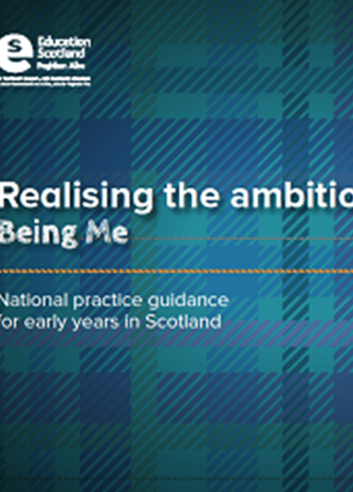 | Realising the Ambition - Being Me - March 2020  National practice guidance which reflects the original principles and philosophy of Building the Ambition and compliments the current policy direction of ELC and early primary education. It aspires to support practitioners in delivering what babies and young children need most and how we can most effectively deliver this in Scotland to give children the best start in life. |  | 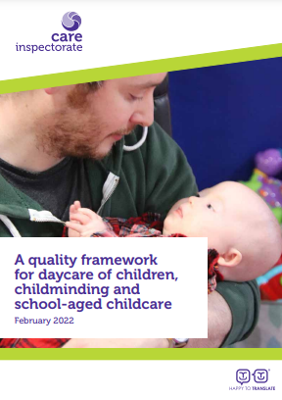 | A Quality Framework for Daycare of Children, Children, Childminding and School-aged Childcare - February 2022  The primary purpose of this quality framework is to support settings to evaluate their own performance. This framework is also used by Care Inspectorate when inspecting EC settings.
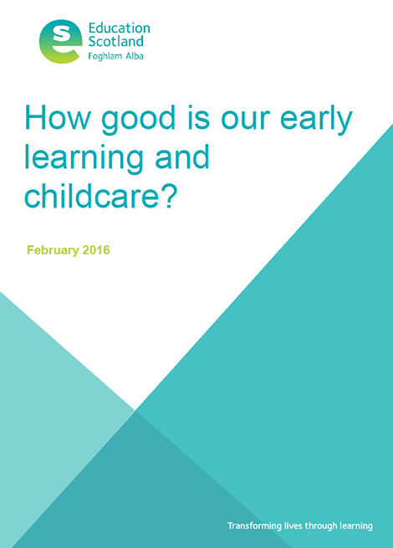 | How good is our early learning and childcare?- February 2016  A framework for self-evaluation which is for all practitioners working with children from birth to starting school. By using the quality indicators, challenge questions and features of highly effective practice, settings can evaluate their practice, identify their strengths and also areas for improvement. This will help settings understand the difference they are making and what they need to do next. |  | 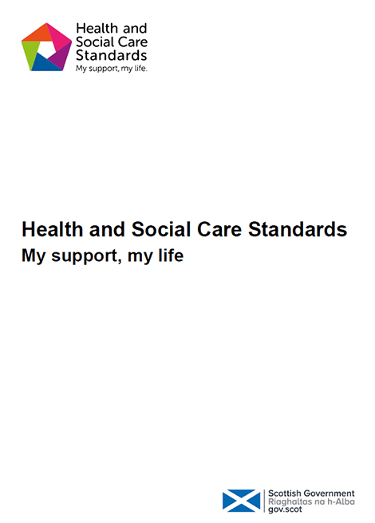 | Health and Social Care Standards – June 2017  These standards should be used as a guideline for how to achieve high quality care for all Health, Social Care and Social Work services in Scotland, including ELC provision. They are the standards used by Care Inspectorate when registering and inspecting ELC settings.
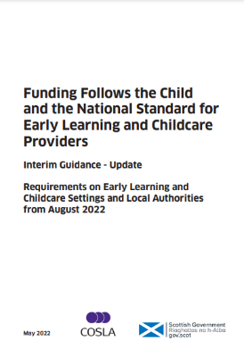 | Funding Follows the Child and the National Standard for ELC Providers - Interim Guidance Update from August 2022  This document sets out how the Funding Follows the Child approach, how settings will meet the National Standard criteria and what the role of local authorities will be in implementing the Approach from August 2020.  Please note this guidance was updated on 30 March 2021 |  | 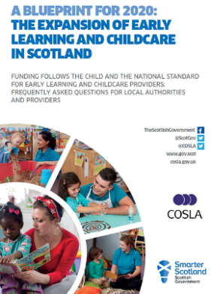 | Funding Follows the Child and the National Standard- FAQs for Local Authorities and Providers – December 2018  This document addresses some of the frequently asked questions from local authorities and providers about the Funding Follows the Child approach and the National Standard criteria.
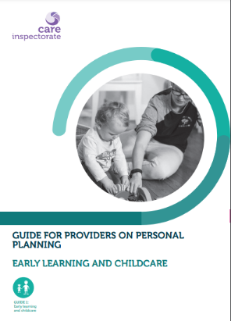 | Guide for Providers on Personal Planning - Early Learning and Childcare  This guide is for managers and their staff to help improve how personal planning is undertaken and to support them in developing personal plans for children, recording ‘what matters’ to a child and how staff are meeting their personal needs. |  | 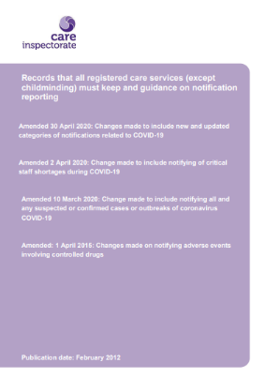 | Records that all care services (except childminding) must keep and guidance on notification reporting – Amended 30 April 2020  A document which sets out all records ELC settings must keep and also provides clear guidance on matters that should be reported to Care Inspectorate.
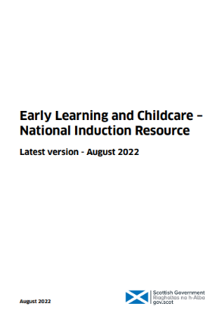 | ELC National Induction Resource - August 2022  A resource developed to support newly appointed practitioners in ELC settings. It sets out how they can expect their employer to support them in their new role, includes links to the range of national resources which are available to support them and will support them to develop in their vital role in giving our children the best possible start. Please note that this resource was updated in January 2022 |  | 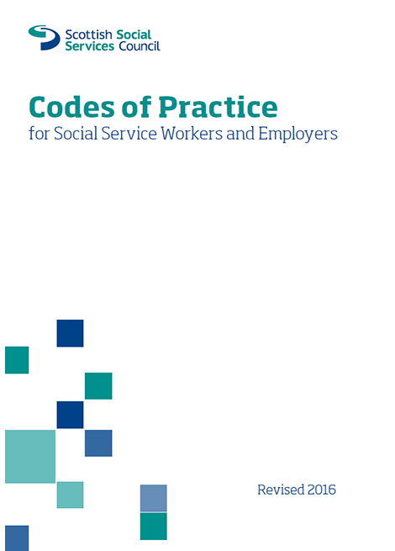 | Codes of Practice for Social Service Workers and Employers – Revised version 2016  The SSSC Codes of Practice set out:  - The standards of practice and behaviour expected of everyone who works in social services in Scotland  - The standard expected of employers of social service workers in Scotland
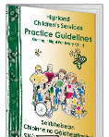 | GIRFEC & The Highland Practice Model - 2017  Getting It Right For Every Child (GIRFEC) is the national approach in Scotland to improving outcomes and supporting the wellbeing of our children and young people by offering the right help at the right time by the right people. Everyone working with children across Highland uses the Highland Practice Model. This guidance helps people to understand what support is required to improve outcomes for children and young people. |  | 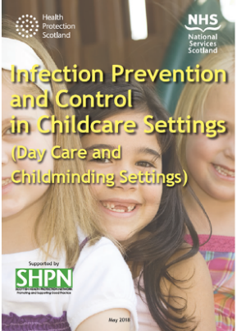 | Infection Prevention and Control in Childcare Settings - May 2018  Staff working with children in childcare settings have a ‘duty of care’ to provide a safe environment for children. This document provides guidance on infection prevention and control for staff working within ELC settings, childminders, after school clubs and holiday clubs. It should also be used by staff involved in all outdoor activities for children.
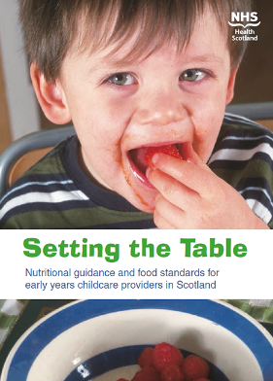 | Setting the Table - 2014  This guidance gives childcare providers standards for food provision and practical solutions which are aimed at making it easier for them to understand the positive difference they can make to a child’s nutritional intake and ultimately their future health. |  | 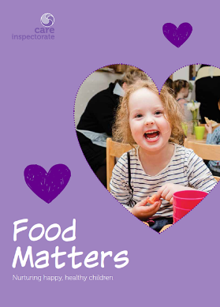 | Food Matters - 2018  A resource which highlights examples of good practice from across the ELC sector. It celebrates the many ways in which ELC settings are supporting children to have positive eating experiences and enjoy well-balanced nutritious food.
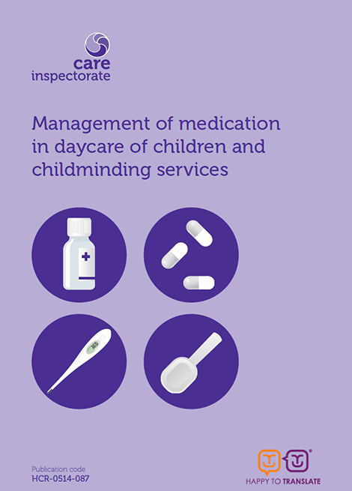 | Management of Medication in Daycare of Children and Childminding - 2014  Guidance which provides information on what needs to be in policies and procedures for:  - Storage and administration of medicine  - Consent to treatment  - Record keeping  - Management of fever  - Minor ailments  Staff training |  | 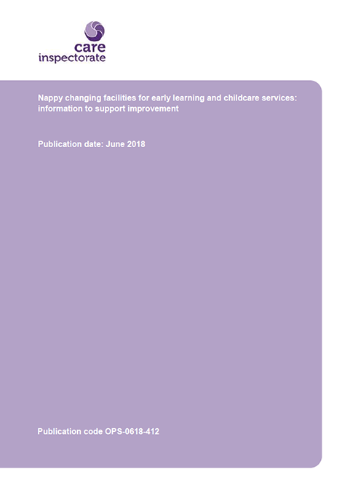 | Nappy Changing Guidance for Early Years and Childcare Services – June 2018  Guidance on the standards required when providing nappy changing or personal care facilities for young children
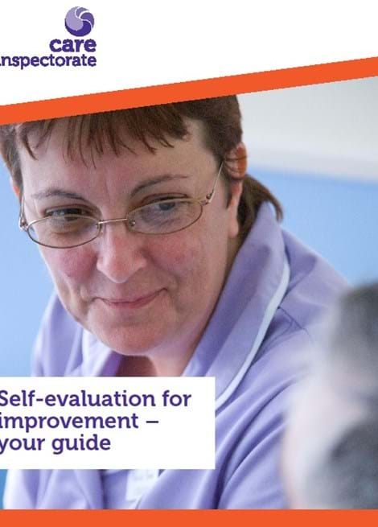 | Self-evaluation for improvement - your guide - 2019  Self-evaluation can be a powerful tool to identify what’s working well and to identify and support areas for improvement. This guide helps services across all care settings, including ELC settings, understand how they can evaluate their own performance. |  | 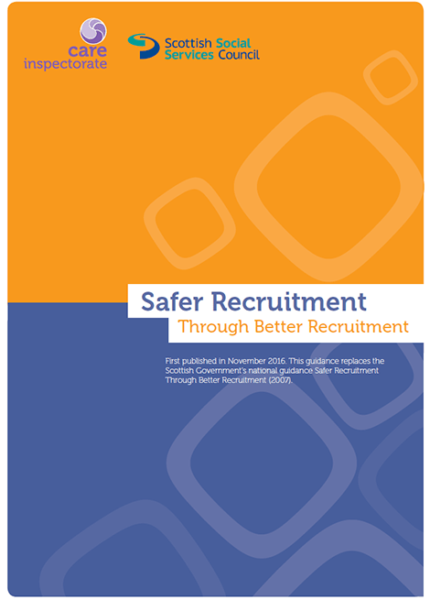 | Safer Recruitment through Better Recruitment – November 2016  This resource is good practice guidance intended to help employers, especially those in social care, early education and childcare and social work to meet existing requirements in relation to the safer recruitment and selection of people who work with individuals who receive support and care from social services in Scotland.
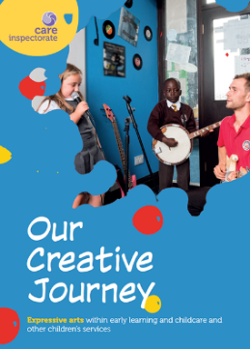 | Our Creative Journey - 2017  Creative play helps children flourish as confident, resilient and happy individuals and is vital for child development. This resource features good and innovative practical examples, including art, drama, pretend play, music and song, model making, loose-parts play, storytelling and dance. |  | 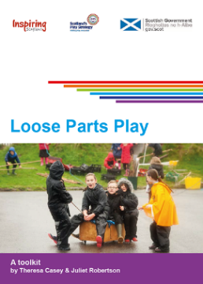 | Loose Parts Play Toolkit - 2019  Loose parts are about real-world learning for children. The impact of facilitating quality loose parts play is improved health and wellbeing.  This toolkit provides practical guidance to those who work with children and young people of all ages.
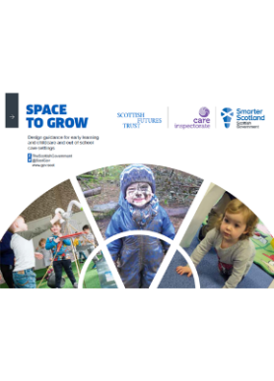 | Space to Grow – June 2017  This guidance is a key tool for providers, planners, architects, designers and others when extending or refurbishing ELC and out of care services, particularly in preparation for 1140 hours of funded provision. |  | 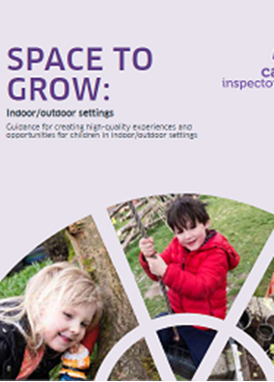 | Space to Grow: Indoor/Outdoor Settings - 2019  A resource which provides detail and support for those considering developing indoor/outdoor settings. It should be used in conjunction with Space to Grow, Out to Play, My World Outdoors and the Practice Note: Early learning and Childcare: delivering High Quality Play and learning Environments Outdoors.
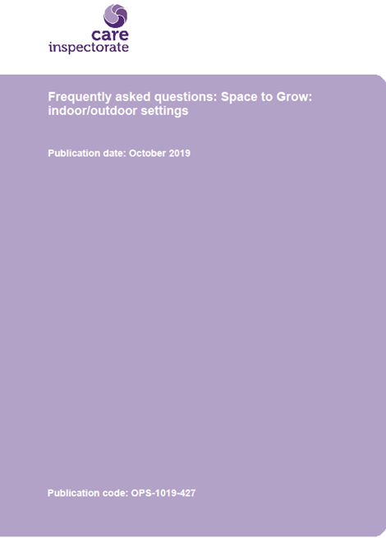 | Space to Grow - Frequently Asked Questions - October 2019  A resource to support implementation of Space to Grow: Indoor/Outdoor Settings |  | 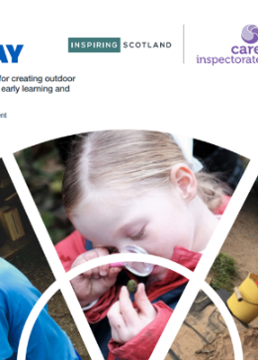 | Out to Play – December 2018  A how-to-guide helps to equip ELC practitioners with the skills and knowledge needed to make playing and learning outdoors an everyday experience for children
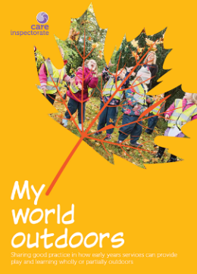 | My World Outdoors - 2016  There is significant evidence that playing outside is more than just fun; it can contribute positively to child development, child health and early learning. In this resource, examples of effective practice have been grouped together around the wellbeing indicators, where children are safe, healthy, achieving, nurtured, active, respected, responsible and included. |  | 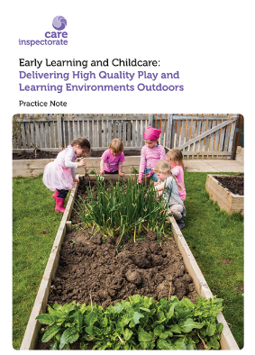 | Early Learning and Childcare Delivering Play and Learning Environments Outdoors: Practice Note - 2018  This short document contains descriptions of settings using the outdoors as part of their space for registered numbers of children. It supports providers to consider new and innovative models of early learning and childcare.
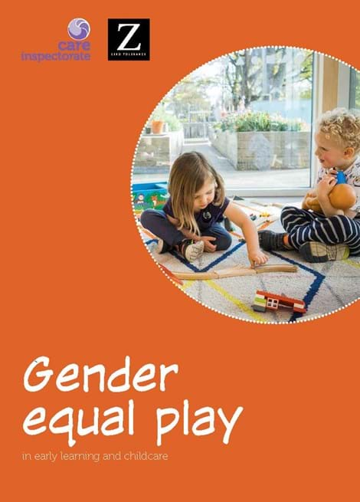 | Gender Equal Play in Early Learning and Childcare - 2018  A resource that promotes gender equality in how children experience early learning and childcare and gives practitioners working in ELC practical tips on avoiding gender stereotyping. It explains the importance of challenging gender stereotyping and provides ideas and examples for early years practitioners of existing good practice. |  | 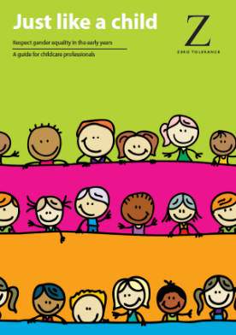 | Just like a child - 2013  A guide to preventing gender stereotyping in the early years is aimed at childcare professionals who work directly with very young children, and who are in contact with their parents and carers. It provides resources to support professionals and parents to raise children who are not limited by outdated or restricted ideas of what is suitable for boys and for girls.
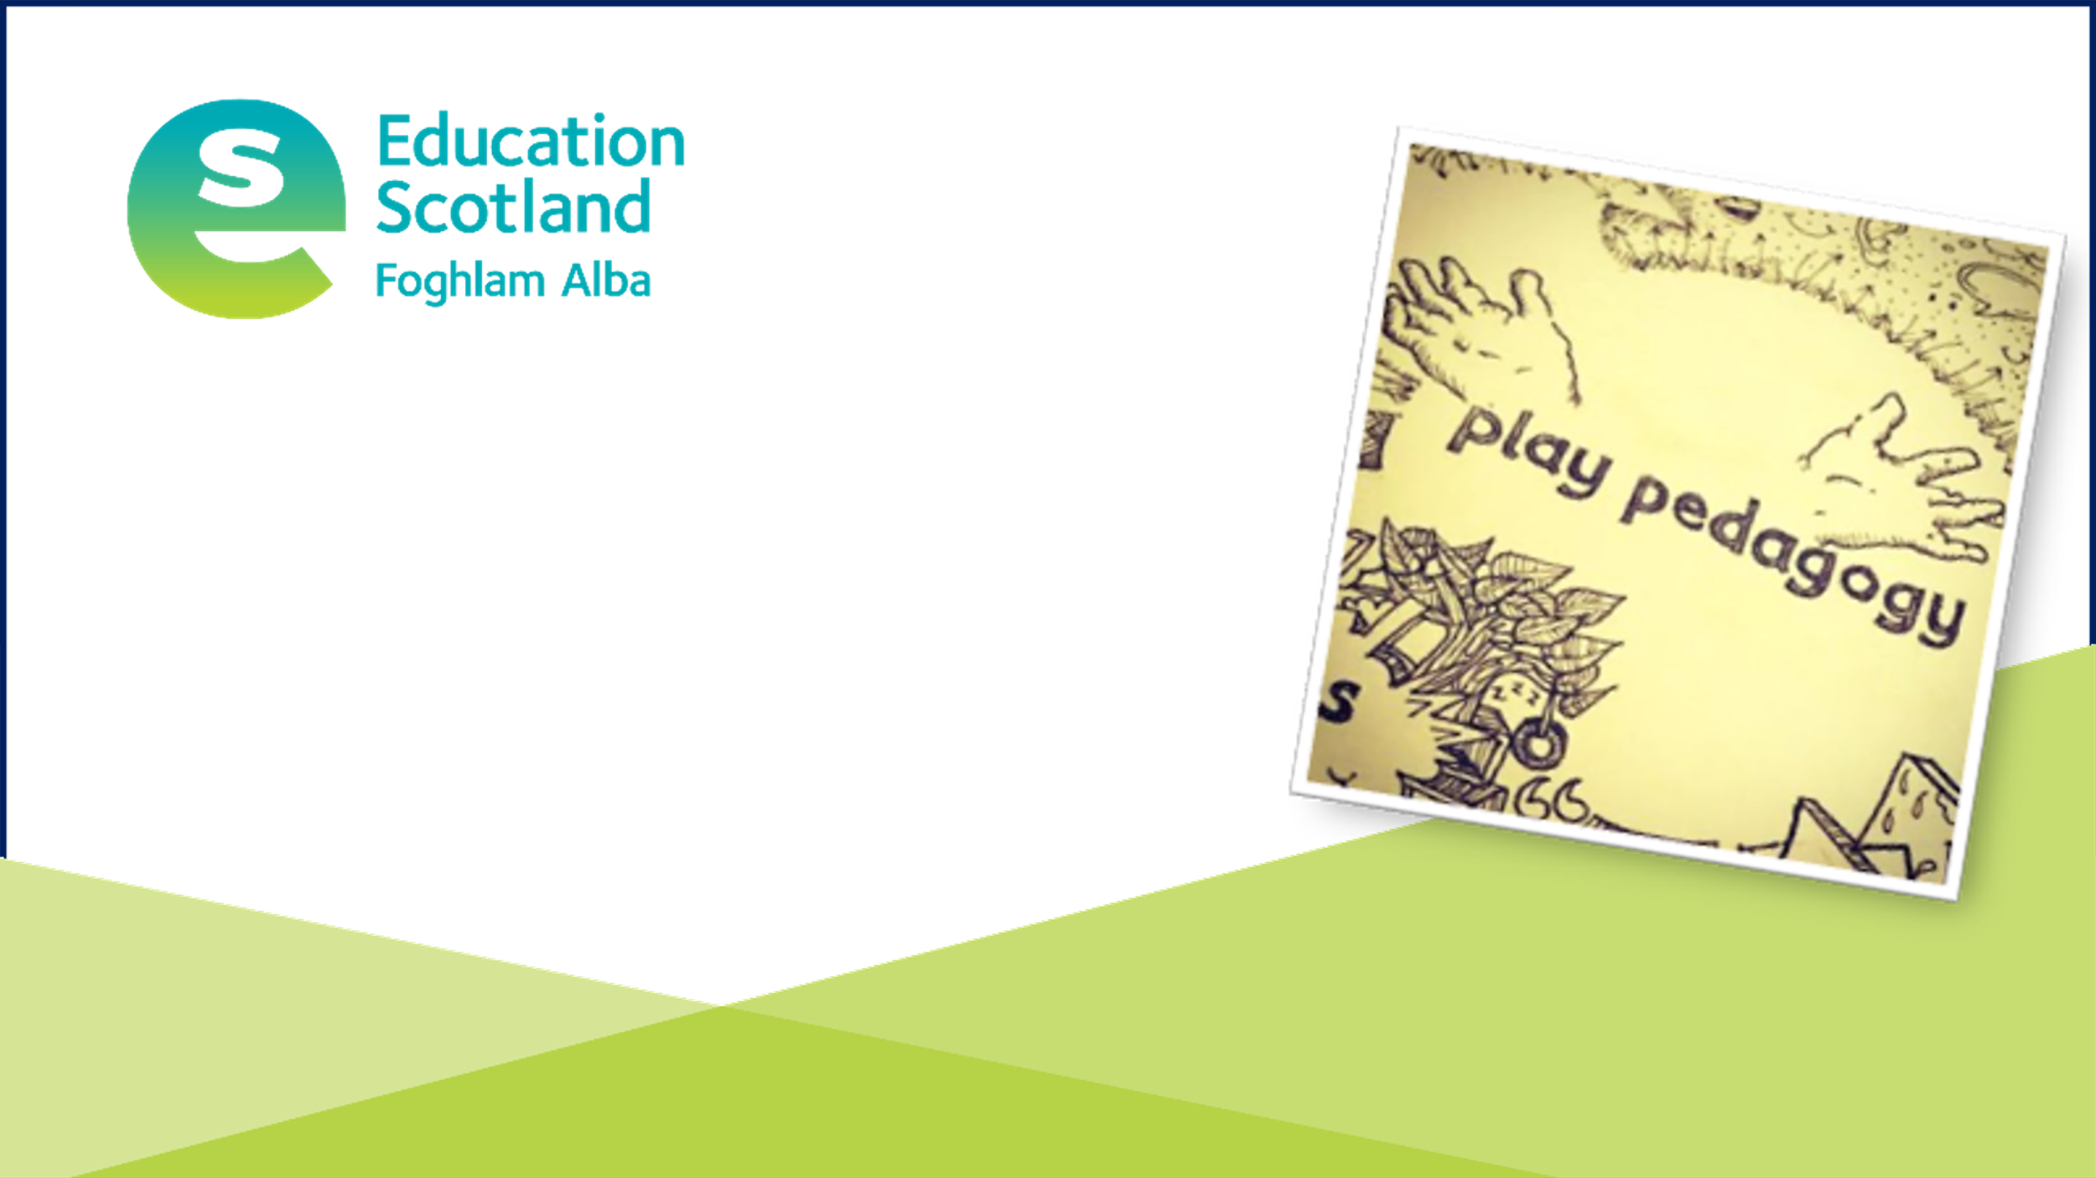 | Early Level Play Pedagogy Toolkit - Updated 15 May 2020  This toolkit aims to support practitioners working with children in the Early Level to appropriately use play pedagogy to support learning and development.  It is designed to be used in conjunction with Curriculum for Excellence and the refreshed national practice guidance for early years in Scotland ‘Realising the Ambition: Being Me’ |  | 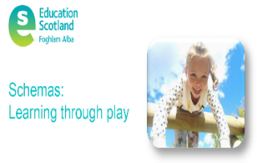 | Schemas - Learning through Play  Have you ever watched a child at play and wondered why they are continually repeating certain actions? If so, it is possible that the child is engaging in schematic play. This document explains what that means and how you can support their learning through schematic play.
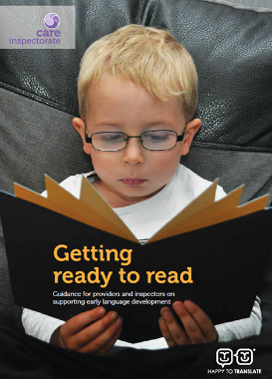 | Getting Ready to Read - 2016  A document which highlights some of the key aspects of early learning and childcare provision that make a difference to children having good early language skills. |  | 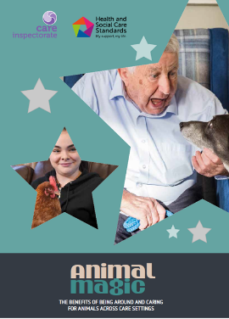 | Animal Magic - 2018  A resource which celebrates the amazing difference being around and caring for animals makes for many children and adults using a range of care services.  There are 18 short documentary videos to accompany Animal Magic.
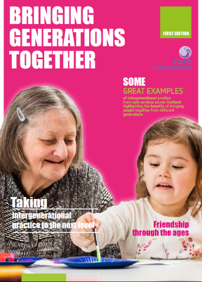 | Bringing Generations Together - 2019  Some great examples of generational practice from care services across Scotland highlighting the benefits of bringing people together from different generations. |  | 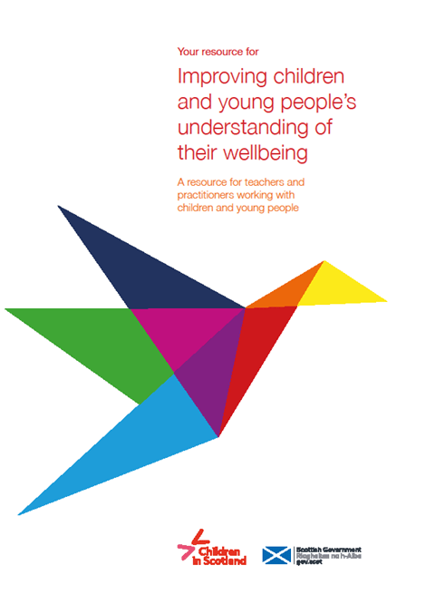 | Improving Children and Young Peoples Understanding of their Wellbeing - 2019  A resource which provides a wide range of activities, practical materials, links to books and additional external resources for practitioners to support the wellbeing needs of children and young people.
 | Autism Toolbox  This online resource is free to use and aims to support the inclusion of autistic learning in early learning and childcare, and primary and secondary schools. The Toolbox supports the Scottish Strategy for Autism and covers topics including understanding autism, supporting learners and their families and transitions. |  | 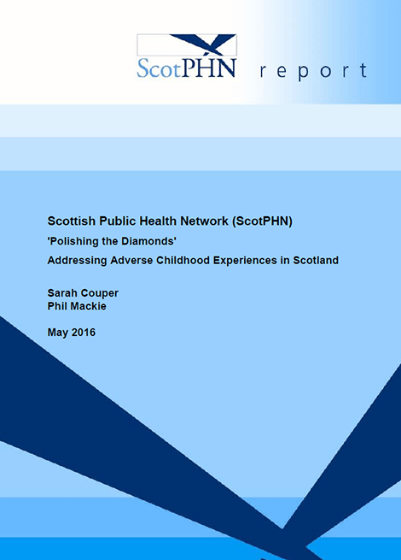 | Polishing the Diamonds - Addressing Adverse Childhood Experiences in Scotland – May 2016  An experienced Health Visitor once said that children are like diamonds: their potential is inherent, but they need to be polished with care and attention. Sadly, this is not the case with all our children in Scotland as a significant number are being subjected to Adverse Childhood Experiences (ACEs) This is an overview of ACEs. What are they? What impact can they have? What can be done about ACEs?
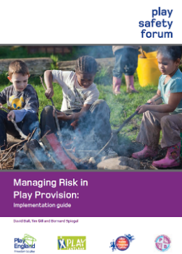 | Managing Risk in Play Implementation Guide - 2013  Children need and choose exciting places to play, which inevitably means managing situations which are inherently risky. This document introduces the concept of balancing risks with benefits in a process of risk-benefit assessment that has now become recognised as an appropriate approach to risk management across play, leisure and education.

