Highland Council: Early Years Profiling and Reporting
Highland Council is supporting ongoing Profiling and Reporting to enable increased family engagement across all Early Learning and Childcare (ELC) settings and schools. In ELC, with the learner at the centre, practitioners support ongoing profiling and reporting through:
∙ a child centred curriculum
∙ quality observations and learning conversations
∙ effective family engagement.

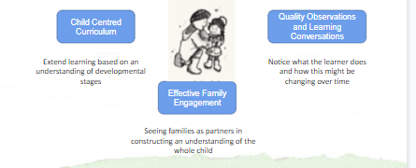
Profiling and Reporting in Early Learning and Childcare

Effective Profiling in Highland is owned by the learner and involves/ includes:
∙ a play-based curriculum which meets the needs of all children, driven by children’s interests
∙ high quality observations based on key learning which evidence progress
∙ learning conversations which identify next steps/personal targets
∙ family engagement in children’s development and learning, impacting positively on the progress children make
∙ recognition and celebration of wider achievement – joining up the dots between Early Learning and Childcare (ELC) settings and home.

The Profile is owned by the learner and should include:
1. Being Me! (All About Me) – including personal information about the learner and their interests
2. Developmental Overviews – informed by observation
3. Next Steps/Personal Targets – which are identified by learners through learning conversations

4. Quality Observations – which identify the knowledge and skills which learners develop across the curriculum
5. Wider Achievements – detailing the achievements out with the ELC setting, at home or in the wider community.
_____________________________________________________________________________________________
Progress in learning will be shared with families through a number of individual and group opportunities. Early Learning and Childcare (ELC) settings should work with their community to identify the most appropriate ways of engaging families. Outlined below are some of the examples of engagement currently offered by ELC settings.

Individual Reporting Opportunities | Whole School/Class/Group Reporting Opportunities
Family meetings which share children’s progress and next steps/targets | Curriculum Information sessions, e.g. early literacy and numeracy workshops | Class blogs/school website/online platforms
Regular opportunities for children to share their profile with their family | Learning walls/Floorbooks/  displays | Newsletters
‘Stay, Play and Learn’ sessions which allow for individual dialogue | Family volunteering* and ‘Stay, Play and Learn’ sessions | ELC showcasing the learning events

*Family volunteering – please ensure you comply with the PVG requirements. For more information see the PVG Guidance for Schools and Parent Councils (June 2025)

